**RESTAURANT WEBSITE USING HTML AND CSS**

END TERM REPORT

*By*

**Sagar Admane RK22EGA20**

**Harsh Raj RK22EGA23**

**Sumit Yadav RK22EGB53**

**Section: K22EG**



**Department of Intelligent Systems**

**School of Computer Science Engineering**

**Lovely Professional University, Jalandhar**

**NOV-2022**

**Student Declaration**

This is to declare that this report is written by us. No part of the report is copied from other sources. All information included from other sources have been duly acknowledged. We aver that if any part of the report is found to be copied. We shall take full responsibility for it.

<<Signature of Student>>

<<Name of student>>

<<Roll No: _________>>

<<Signature of Student>>

<<Name of student>>

<<Roll No: _________>>

<<Signature of Student>>

<<Name of student>>

<<Roll No: _________>>

Place:

Date:

**TABLE OF CONTENTS**

**TITLE**

**1.Background and Objectives of Project Assigned………………………… 1**

**1.1……………………………………………………………………………… 1**

**1.1.1…………………………………………………………………………….. 3**

**1.1.2 ……………………………………………………………………………. 5**

**1.2 ……………………………………………………………………………… 7**

**1.2.1 ……………………………………………………………………………… 7**

**1.2.2 ……………………………………………………………………………… 9**

**1.2.3 ……………………………………………………………………………… 10**

**2. Description of Project …………………………………………………………… 14**

**2.1 ………………………………………………………………………………….. 17**

**2.2 …………………………………………………………………………………. 18**

**BONAFIDE CERTIFICATE**

Certified that this project report “Restaurant web page” is the bonafide work of “Sagar Admane, Harsh Raj and Sumit Yadav” who carried out the project work under my supervision.

<<Signature of supervisor>>

<<Name of supervisor>>

<<Academic Designation>>

<<ID of supervisor>>

<<Department of Supervisor>>

**BACKGROUND AND OBJECTIVES OF PROJECT ASSIGNED:**

**BACKGROUND:**

We used our own creativity and ideas to build the web page. Here we used simple HTML code to provide structure to web page and we used CSS to provide the design to the web page.

We tried to create a “Restaurant web page” with the knowledge that our faculty member has shared with us.

We used many elements such as <a> <div> and many more. We created a simple web page in which we used <a> to link different web pages. We also used image in background to fix the background. We used hover tag to highlight the link that we provided for different web page.

**MOTIVATION:**

We get the idea of creating the restaurant web page from the “Zomato” website. We tried to create the web page for the restaurant in which the person can access to the web page, ask their queries in personal and some information regarding the restaurant.

Our biggest motivation was our faculty member Mr. Bhupinder Singh, who helped us every time wherever we were having trouble in moving forward. He helped and guided us in every possible situation.

**OUTCOME:**

We have successfully created a web page for restaurant. It contains the blog page of our restaurant.

We also learned about many of the new tags and how they are used in a web page and what are their functions and features.

After gaining some knowledge and trying to implement it on our code we get different result. We learned many new elements and tags; we cleared our doubts on some respective topics and we successfully created a web page.

**OBJECTIVES:**

This little project has been done as a part of my course for the CSE at Lovely Professional University. Supervised by Bhupinder Singh sir. Objective of the project is to build the html website and clear the concepts of HTML and CSS.

**IDEA:**

It has been the first experience of doing such a tiny project full of creative interest. We wanted to make our project an attractive website with creativity, we used different programming processes like HTML for creating a basic website, and to get a radiant look we used CSS part and for design stylishly the web. These programming processes are easy to approach and understand the coding.

**SCREENSHOTS :**

**Home Page:**

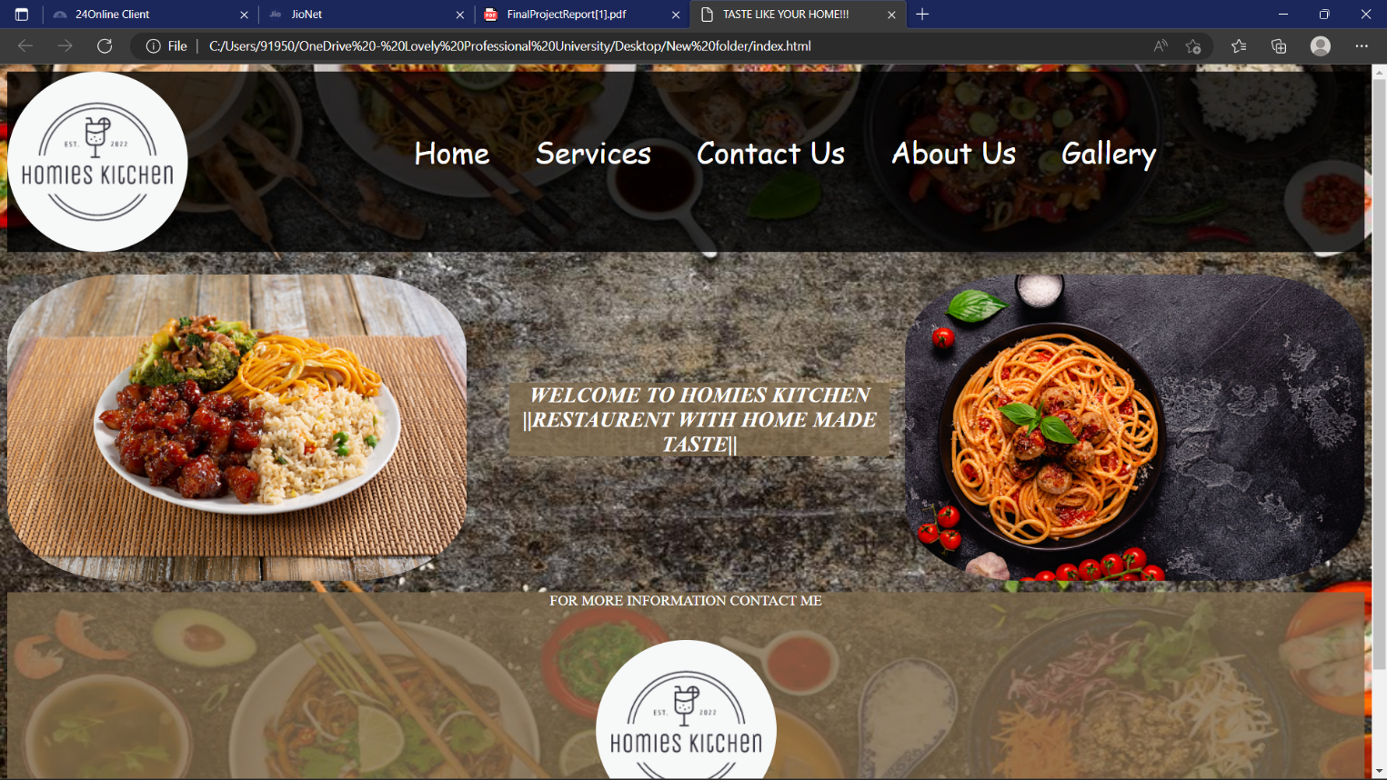

**Services:**

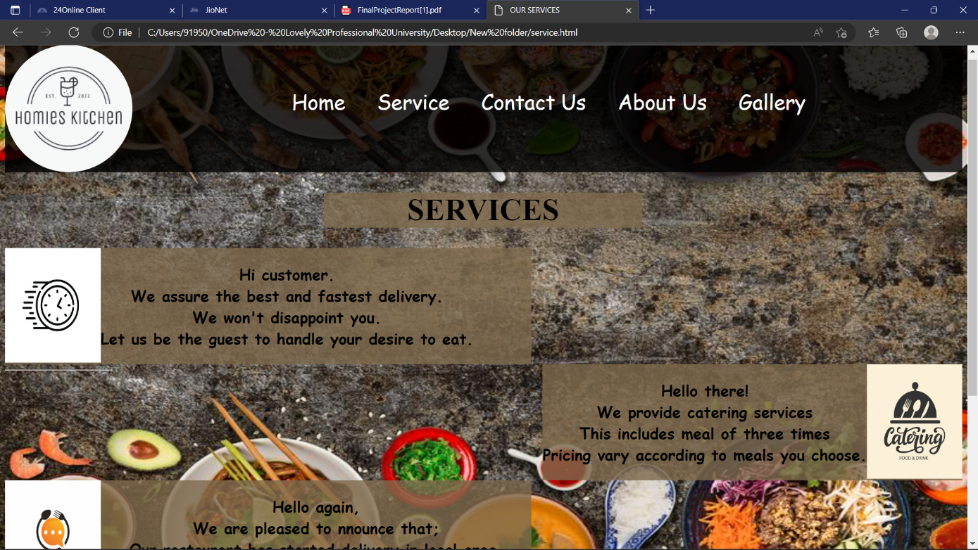

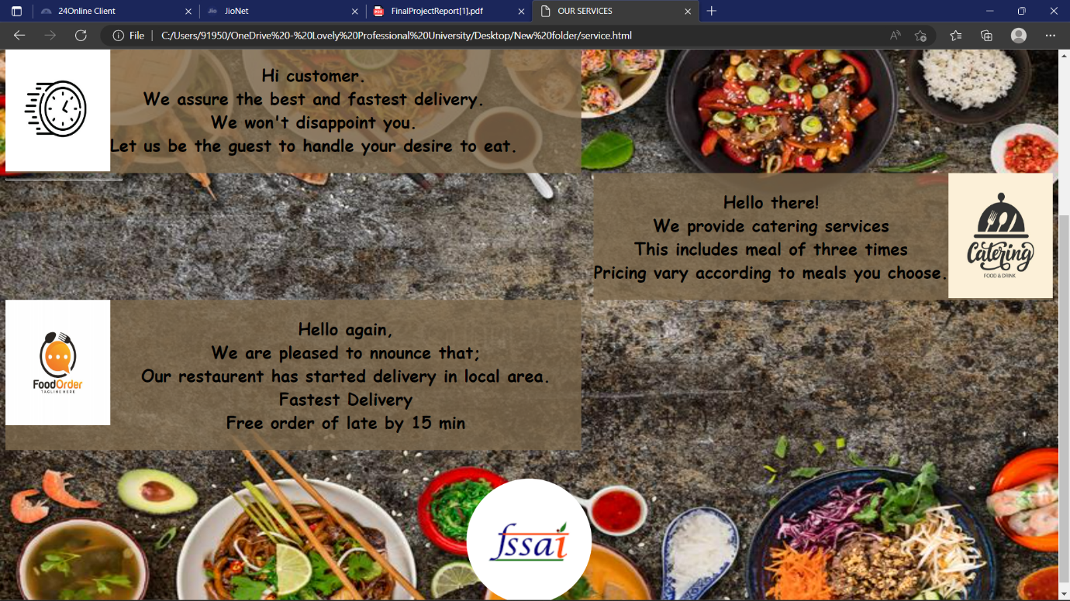

**Contact Us:**

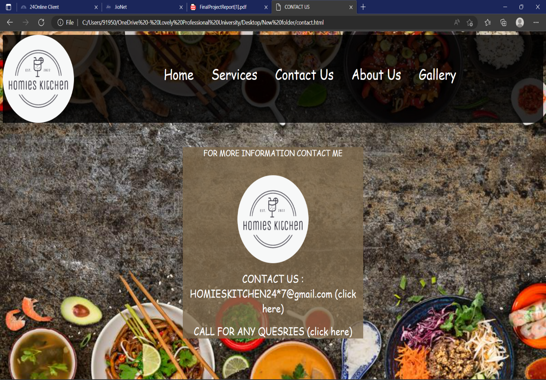

**About Us:**

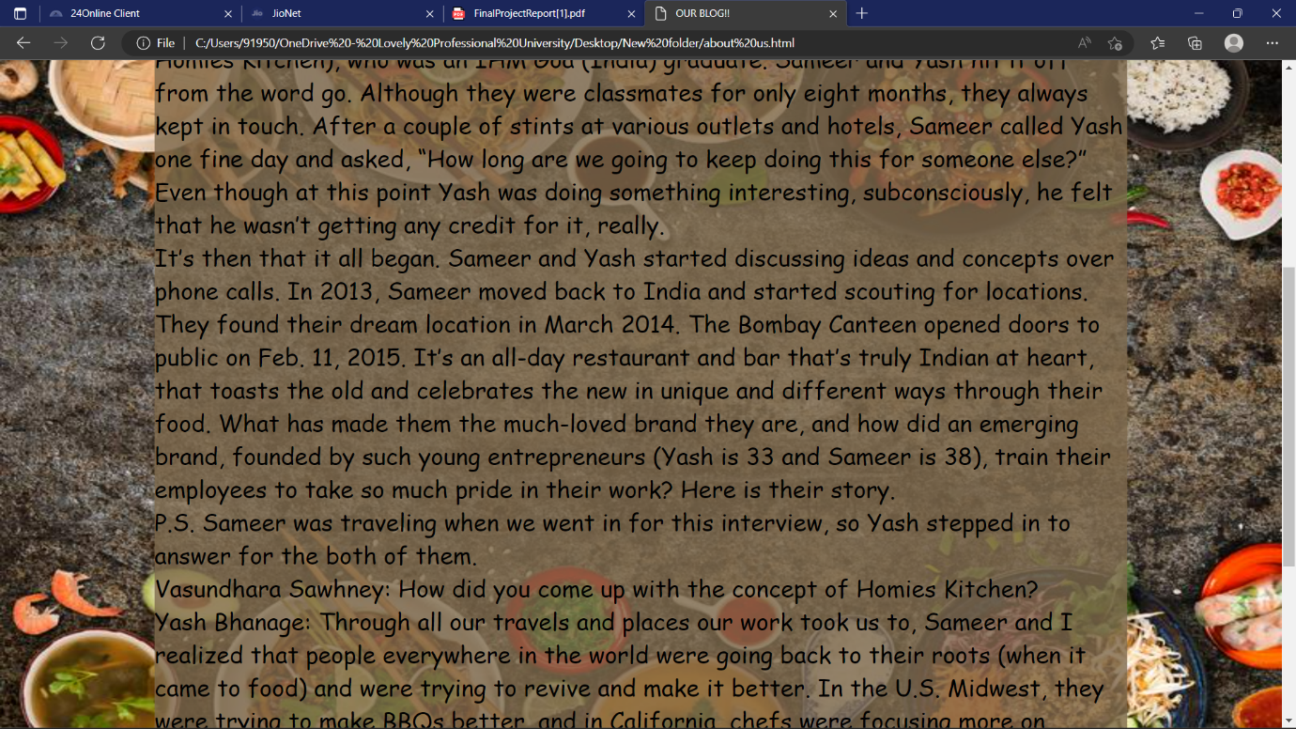

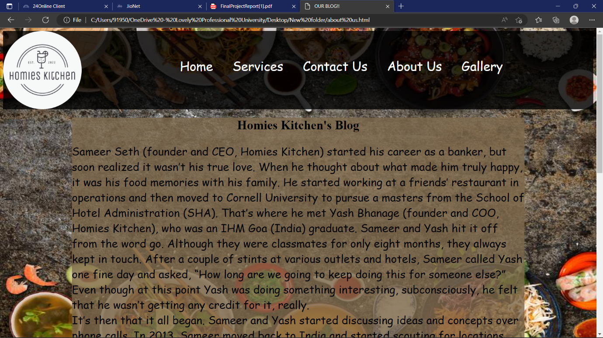

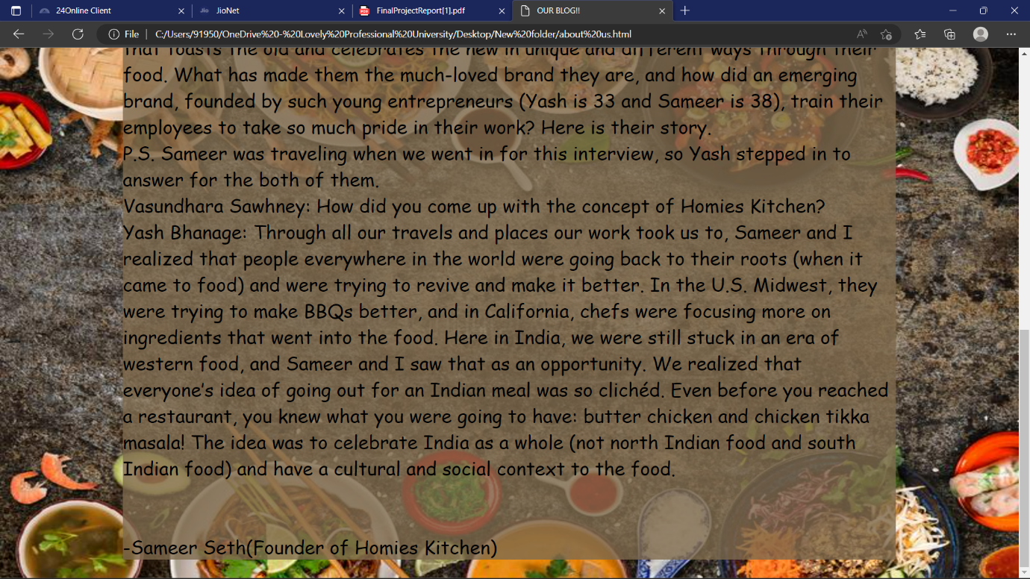

**Gallery:**

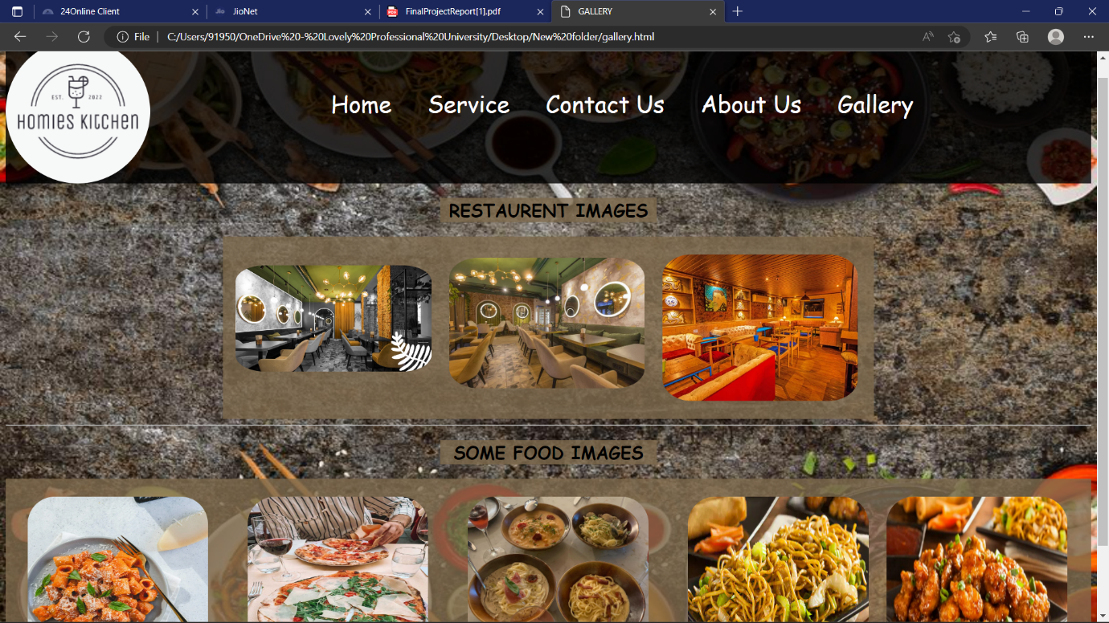

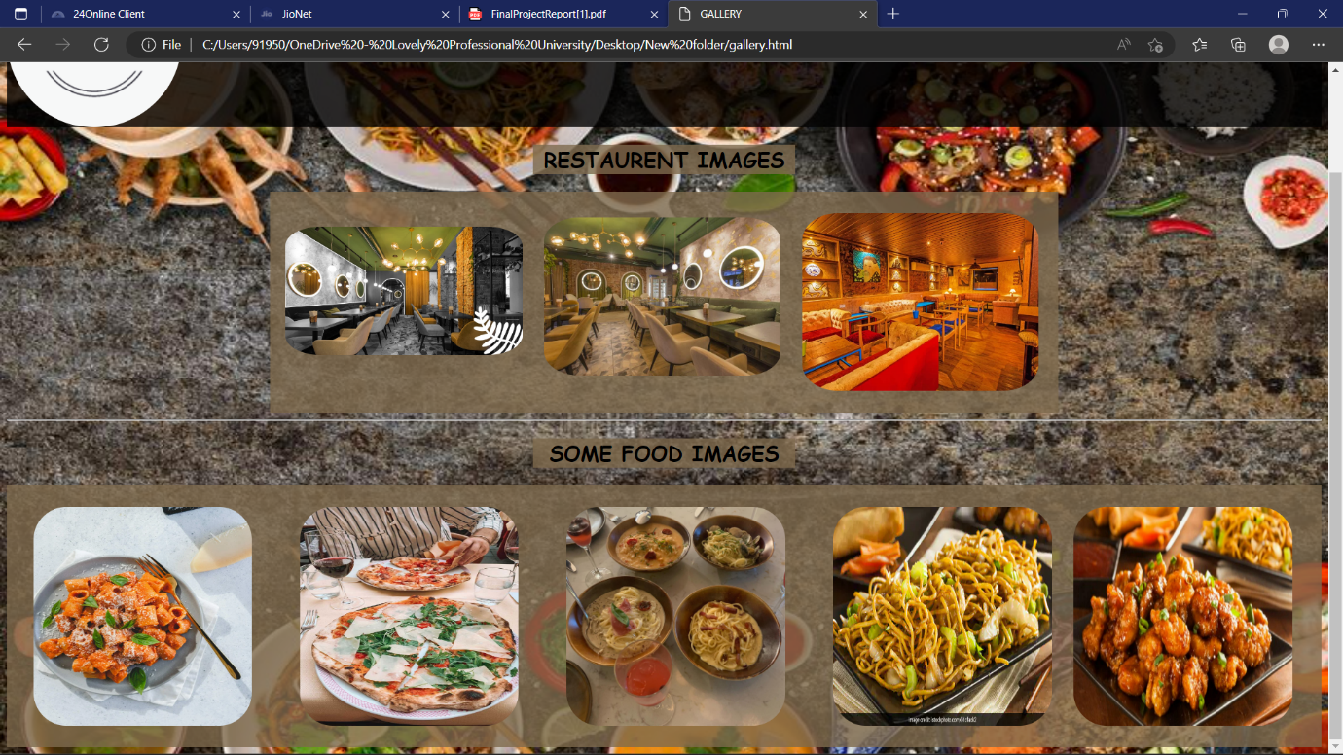

**CODE:**

For Home Page:

<!DOCTYPE html>

<html lang="en">

<head>

<meta charset="UTF-8">

<meta name="viewport" content="width=device-width, initial-scale=1.0">

<title>TASTE LIKE YOUR HOME!!!

</title>

<link rel="stylesheet" href="style.css">

</head>

<body>

<div class="div1">

<img src="homieskitchen.png" alt="HOMIES KITCHEN LOGO" style="border-radius:50%;">

<ul>

<li>

<a href="index.html">Home

</a>

</li>

<li>

<a href="service.html">Services

</a>

</li>

<li>

<a href="contact.html">Contact Us

</a>

</li>

<li>

<a href="about us.html">About Us</a></li>

<li>

<a href="gallery.html">Gallery

</a>

</li>

</div>

<div class="div2">

<img src="bg1.jpg" alt="food" class="bg1" style="border-radius:25%">

</div>

<div style="float:right; padding-top:25px;">

<img src="bg2.jpg" alt="italian" class="bg2" style="border-radius:25%">

</div>

<div class="para">

<p style="text-align:center; font-family:Times New Roman;"><b><i> WELCOME TO HOMIES KITCHEN </b><br>

<b>||RESTAURENT WITH HOME MADE TASTE||</b></i></p>

</div>

<div class="div4">

<p style="color:white; text-align:center">FOR MORE INFORMATION CONTACT ME</p><br>

<img src="homieskitchen.png" alt="logo" class="center" style="border-radius:50%;"><br>

<a href="mailto:homieskitchen@gmail.com" style="display:block;text-align:center">CONTACT US : HOMIESKITCHEN24*7@gmail.com (click here)</a><br>

<a href="tel:+919503036962" style="display:block;text-align:center">CALL FOR ANY QUESRIES (click here)</a>

</div>

</body>

</html>

For Services:

<!DOCTYPE html>

<html lang="en">

<head>

<meta charset="UTF-8">

<meta name="viewport" content="width=device-width, initial-scale=1.0">

<title>OUR SERVICES</title>

<link rel="stylesheet" href="style.css">

</head>

<body>

<div class="div1">

<img src="homieskitchen.png" alt="logo" style="border-radius:50%;">

<ul>

<li><a href="index.html">Home</a></li>

<li><a href="service.html">Service</a></li>

<li><a href="contact.html">Contact Us</a></li>

<li><a href="about us.html">About Us</a></li>

<li><a href="gallery.html">Gallery</a></li>

</div>

<div class="my">

<h1>SERVICES</h1>

</div>

<div class="my1">

<img src="fast.jpg" alt="fast" class="a1">

<p style="align:center"><b>Hi customer.<br>

We assure the best and fastest delivery.<br>

We won't disappoint you.<br>

Let us be the guest to handle your desire to eat.</b></p>

</div>

<div class="my2">

<p><b>Hello there!<br>

We provide catering services<br>

This includes meal of three times<br>

Pricing vary according to meals you choose.

</b></p>

<img src="catering.jpg" alt="catering" class="a1">

</div>

<hr>

<div class="my3">

<img src="order.jpg" alt="food ordering" class="a1">

<p><b>Hello again,<br>

We are pleased to nnounce that;<br>

Our restaurent has started delivery in local area.

Fastest Delivery<br>

Free order of late by 15 min</b></p>

</div>

<div class="my4">

<img src="download.png" alt="fssai" class="center1" style="border-radius:50%; margin-top:10%">

</div>

</body>

</html>

For Contact Us:

<!DOCTYPE html>

<html lang="en">

<head>

<meta charset="UTF-8">

<meta name="viewport" content="width=device-width, initial-scale=1.0">

<title>CONTACT US

</title>

<link rel="stylesheet" href="style.css">

</head>

<body>

<div class="div1">

<img src="homieskitchen.png" alt="HOMIES KITCHEN LOGO" style="border-radius:50%;">

<ul>

<li>

<a href="index.html">Home

</a>

</li>

<li>

<a href="service.html">Services

</a>

</li>

<li>

<a href="contact.html">Contact Us

</a>

</li>

<li>

<a href="about us.html">About Us</a></li>

<li>

<a href="gallery.html">Gallery

</a>

</li>

</div>

<div class="abc" style="margin-top:55px;">

<p style="color:white; text-align:center; font-size: 120%; font-family: Cursive;">FOR MORE INFORMATION CONTACT ME</p><br>

<img src="homieskitchen.png" alt="logo" class="center" style="border-radius:50%;"><br>

<a href="mailto:homieskitchen@gmail.com" style="display:block;text-align:center; font-size: 150%; font-family: Cursive;">CONTACT US : HOMIESKITCHEN24*7@gmail.com (click here)</a><br>

<a href="tel:+919503036962" style="display:block;text-align:center; font-size: 150%; font-family: Cursive;">CALL FOR ANY QUESRIES (click here)</a>

</div>

</body>

</html>

For About Us:

<!DOCTYPE html>

<html lang="en">

<head>

<meta charset="UTF-8">

<meta name="viewport" content="width=device-width, initial-scale=1.0">

<title>OUR BLOG!!

</title>

<link rel="stylesheet" href="style.css">

</head>

<body>

<div class="div1">

<img src="homieskitchen.png" alt="HOMIES KITCHEN LOGO" style="border-radius:50%;">

<ul>

<li>

<a href="index.html">Home

</a>

</li>

<li>

<a href="service.html">Services

</a>

</li>

<li>

<a href="contact.html">Contact Us

</a>

</li>

<li>

<a href="about us.html">About Us</a></li>

<li>

<a href="gallery.html">Gallery

</a>

</li>

</div>

<div class="my5">

<h1 style="text-align:center;">Homies Kitchen's Blog</h1>

<p class="abc1">Sameer Seth (founder and CEO, Homies Kitchen) started his career as a banker, but soon realized it wasn’t his true love. When he thought about what made him truly happy, it was his food memories with his family. He started working at a friends’ restaurant in operations and then moved to Cornell University to pursue a masters from the School of Hotel Administration (SHA). That’s where he met Yash Bhanage (founder and COO, Homies Kitchen), who was an IHM Goa (India) graduate. Sameer and Yash hit it off from the word go. Although they were classmates for only eight months, they always kept in touch. After a couple of stints at various outlets and hotels, Sameer called Yash one fine day and asked, “How long are we going to keep doing this for someone else?” Even though at this point Yash was doing something interesting, subconsciously, he felt that he wasn’t getting any credit for it, really.<br>

It’s then that it all began. Sameer and Yash started discussing ideas and concepts over phone calls. In 2013, Sameer moved back to India and started scouting for locations. They found their dream location in March 2014. The Bombay Canteen opened doors to public on Feb. 11, 2015. It’s an all-day restaurant and bar that’s truly Indian at heart, that toasts the old and celebrates the new in unique and different ways through their food. What has made them the much-loved brand they are, and how did an emerging brand, founded by such young entrepreneurs (Yash is 33 and Sameer is 38), train their employees to take so much pride in their work? Here is their story.<br>

P.S. Sameer was traveling when we went in for this interview, so Yash stepped in to answer for the both of them.<br>

Vasundhara Sawhney: How did you come up with the concept of Homies Kitchen?<br>

Yash Bhanage: Through all our travels and places our work took us to, Sameer and I realized that people everywhere in the world were going back to their roots (when it came to food) and were trying to revive and make it better. In the U.S. Midwest, they were trying to make BBQs better, and in California, chefs were focusing more on ingredients that went into the food. Here in India, we were still stuck in an era of western food, and Sameer and I saw that as an opportunity. We realized that everyone’s idea of going out for an Indian meal was so clichéd. Even before you reached a restaurant, you knew what you were going to have: butter chicken and chicken tikka masala! The idea was to celebrate India as a whole (not north Indian food and south Indian food) and have a cultural and social context to the food.<br>

<br>

<br>

-Sameer Seth(Founder of Homies Kitchen)</p>

</div>

</body>

</html>

For Gallery:

<!DOCTYPE html>

<html lang="en">

<head>

<meta charset="UTF-8">

<meta name="viewport" content="width=device-width, initial-scale=1.0">

<title>GALLERY</title>

<link rel="stylesheet" href="style.css">

</head>

<body>

<div class="div1">

<img src="homieskitchen.png" alt="logo" style="border-radius:50%;">

<ul>

<li><a href="index.html">Home</a></li>

<li><a href="service.html">Service</a></li>

<li><a href="contact.html">Contact Us</a></li>

<li><a href="about us.html">About Us</a></li>

<li><a href="gallery.html">Gallery</a></li>

</div>

<h2 style="background-color:rgba(126, 106, 77, 0.8); margin-right:40%; margin-left:40%; font-family:Cursive; text-align:center;">RESTAURENT IMAGES</h2>

<div style="display:flex; background-color:rgba(126, 106, 77, 0.8); margin-right:20%; margin-left:20%;">

<img src="restaurent1.jpg" alt="restaurent images" class="gallery" style="margin-top:40px; margin-left:18px">

<img src="restaurent2.jpg" alt="restaurent images" class="gallery" style="margin-top:30px;">

<img src="restaurent3.jpg" alt="restaurent images" class="gallery">

</div>

<hr>

<h2 style="background-color:rgba(126, 106, 77, 0.8); margin-right:40%; margin-left:40%; font-family:Cursive; text-align:center;">SOME FOOD IMAGES</h2>

<div style="display:flex; background-color:rgba(126, 106, 77, 0.8);">

<img src="italian1.jpg" alt="" class="gallery" style="height:250px; width:250px; margin-left:30px;">

<img src="italian.jpg" alt="" class="gallery" style="height:250px; width:250px; margin-left:30px;">

<img src="italian2.jpg" alt="" class="gallery" style="height:250px; width:250px; margin-left:30px;">

<img src="chinese.jpg" alt="" class="gallery" style="height:250px; width:250px; margin-left:30px;">

<img src="chinese1.jpg" alt="" class="gallery" style="height:250px; width:250px; ">

</body>

</html>

For CSS:

.div1{

display:flex;

background-color : rgba(0, 0, 0, 0.8);

}

li{

list-style:none;

font-family:Cursive;

}

ul{

display:flex;

padding:25px;

padding-left:15%

}

.divimg1{

height:75px;

width:75px;

padding:25px

}

li{

padding:25px;

font-size:200%

}

a{

text-decoration:none;

color:white

}

a:hover{

color:red;

}

body{

background-image: url('bg.jpg');

background-repeat: no-repeat;

background-attachment: fixed;

background-size: 100% 100%;

}

.div2{

float:left;

padding-top:25px;

}

.div3{

padding-top:25px;

}

.para{

font-size:150%;

color:white;

padding-top:0px;

margin-left:37%;

margin-right:35%;

background-color:rgba(126, 106, 77, 0.8);

margin-top:145px;

display:flex:

font-family:Cursive;

margin-bottom:10%

}

.div4{

width:100%;

background-color:rgba(126, 106, 77, 0.8);

}

.center {

display: block;

margin-left: auto;

margin-right: auto;

}

.my{

text-align:center;

font-size:150%;

background-color:rgba(126, 106, 77, 0.8);

float:center;

width:33.3%;

margin-left:33.3%

}

.a1{

height:180px;

width:150px;}

.my1{

display:flex;

background-color:rgba(126, 106, 77, 0.8);

margin-right:45%;

font-size:150%;

text-align:center;

font-family:Cursive;

}

.my2{

display:flex;

background-color:rgba(126, 106, 77, 0.8);

margin-left:45%;

font-size:150%;

text-align:center;

font-family:Cursive;

float:right;}

.my3{

float:left;

display:flex;

background-color:rgba(126, 106, 77, 0.8);

margin-right:45%;

font-size:150%;

text-align:center;

font-family:Cursive;

}

.center1{

display: block;

margin-left: auto;

margin-right: auto;

height:180px;

}

.my4{

padding-top:18%;}

.abc{

margin-left:33.3%;

margin-right:33.3%;

background-color:rgba(126, 106, 77, 0.8);

margin-top:11%;height:100%

}

.my5{

background-color:rgba(126, 106, 77, 0.8);

margin-left:175px;

margin-right:175px;}

.abc1{

font-size:175%;

font-family:Cursive;}

.gallery{

height:30%;

width:30%;

margin-right:25px;

margin-top:25px;

margin-bottom:25px;

border-radius:15%}

**TECHNOLOGIES AND FRAMEWEORK USED:**

**We use notepad for writing our code and chrome browser to run our program.**

**REFERENCES:**

* **Zomato website:** [**https://www.zomato.com/**](https://www.zomato.com/)
* **W3School:** [**https://www.w3schools.com/**](https://www.w3schools.com/)